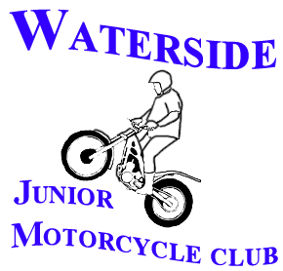
WATERSIDE JMCC TRIALS CLUB

Supplementary Regulations

Waterside JMCC will hold a Restricted Trial, held under the National Sporting Code and the Trials Standing Regulations of the ACU. Final Instructions will be issued at the start of the Trial.

Permit:
Event Type: Club Championship Round 1
Date & Time: Sunday 15th January 2023, Signing On From 9.15am, Start Riding 10.30am
Entry Cost: The entry fee is Adult£20.00, Youth £15.00. You will need a valid ACU licence.
Venue: Harrow Wood Farm, Bransgore, BH23 8DB. Please use this postcode and do not come up through the campsite.
Classes/Routes: Adult & Youth, Beginner To Expert, Including 50/50 and E Routes.
Clerk Of Course: Matt Sleep – 13909
Secretary: Jo Clark - 169666

RIDERS WHO FEEL UNWELL, HAVE ANY COVID-19 SYMPTOMS OR HAVE BEEN AROUND ANYONE WITH SYMPTONS ARE RESPECTFULLY ASKED NOT TO ATTEND. IF ANYONE DEVELOPS ANY SYMPTOMS WITHIN TWO WEEKS FROM THE EVENT THEY ARE ASKED TO LET US KNOW ASAP.

Genral Regulations:
- Open to all Riders with a valid ACU Licence. *Youths must be accompanied by a parent/guardian at all times*

- Championship Points will only be allocated to Waterside JMCC Club Members. Membership forms are available online or at a trial.

Entry/Signing On Regulations:
- The session will be open to everyone and on the day entry will be accepted.

- Please bring your pre completed entry form with the correct entry fee (Cash or Cheque). BACs payment in advance will be an option. Entry forms in a limited quantity will be available on the day.

- Riders must provide details of an emergency contact, who is available on the day of the trial. This info should be recorded on the ‘Signing On Form’ for you.

Additional Information:
- You are asked to ride sensibly and within your ability.

- Please take all litter home with you.

- Spectators are allowed at trials.

- Dogs should not be left in vehicles and are to be kept on a lead at all times. They are also not allowed into the campsite or past the end of the trials area.

- Toilet facilities can be accessed via the campsite. Please leave the facilities in a clean and respectable state. Please also ensure you conduct yourself in a polite and courteous manner whilst on the campsite.

We ask that you read these regulations fully and comply with all that we ask. If we feel that you are not adhering to the regulations or any other given instructions, we will ask you to leave and we may not accept your entry to future events.

WATERSIDE JMCC

